CSS & Responsive Design

We can use responsive design to resize or reposition elements on a web application to improve the user experience by matching the page to the user's device.

Review this article [https://blog.froont.com/9-basic-principles-of-responsive-web-design/ (Links to an external site.)](https://blog.froont.com/9-basic-principles-of-responsive-web-design/) and from each of the 9 highlighted principles, understanding these concepts, select your approach to each of the elements on your pages and indicate your approach to not less than four (4) of the following ideas.

* *responsive vs adaptive design*
* *using static or relative sizes?*
* *flow or static positioning for headers/footers/background images...*
* *using breakpoints*
* *max and min values?*
* *nesting objects (use partial views?)*
* _design for mobile- or desktop- first
* *fonts*
* *vector vs bitmaps*

**Submit (4 tasks!)** Document (MS-Word or PDF) with **screenshots AND descriptive text** illustrating

1. Desktop View

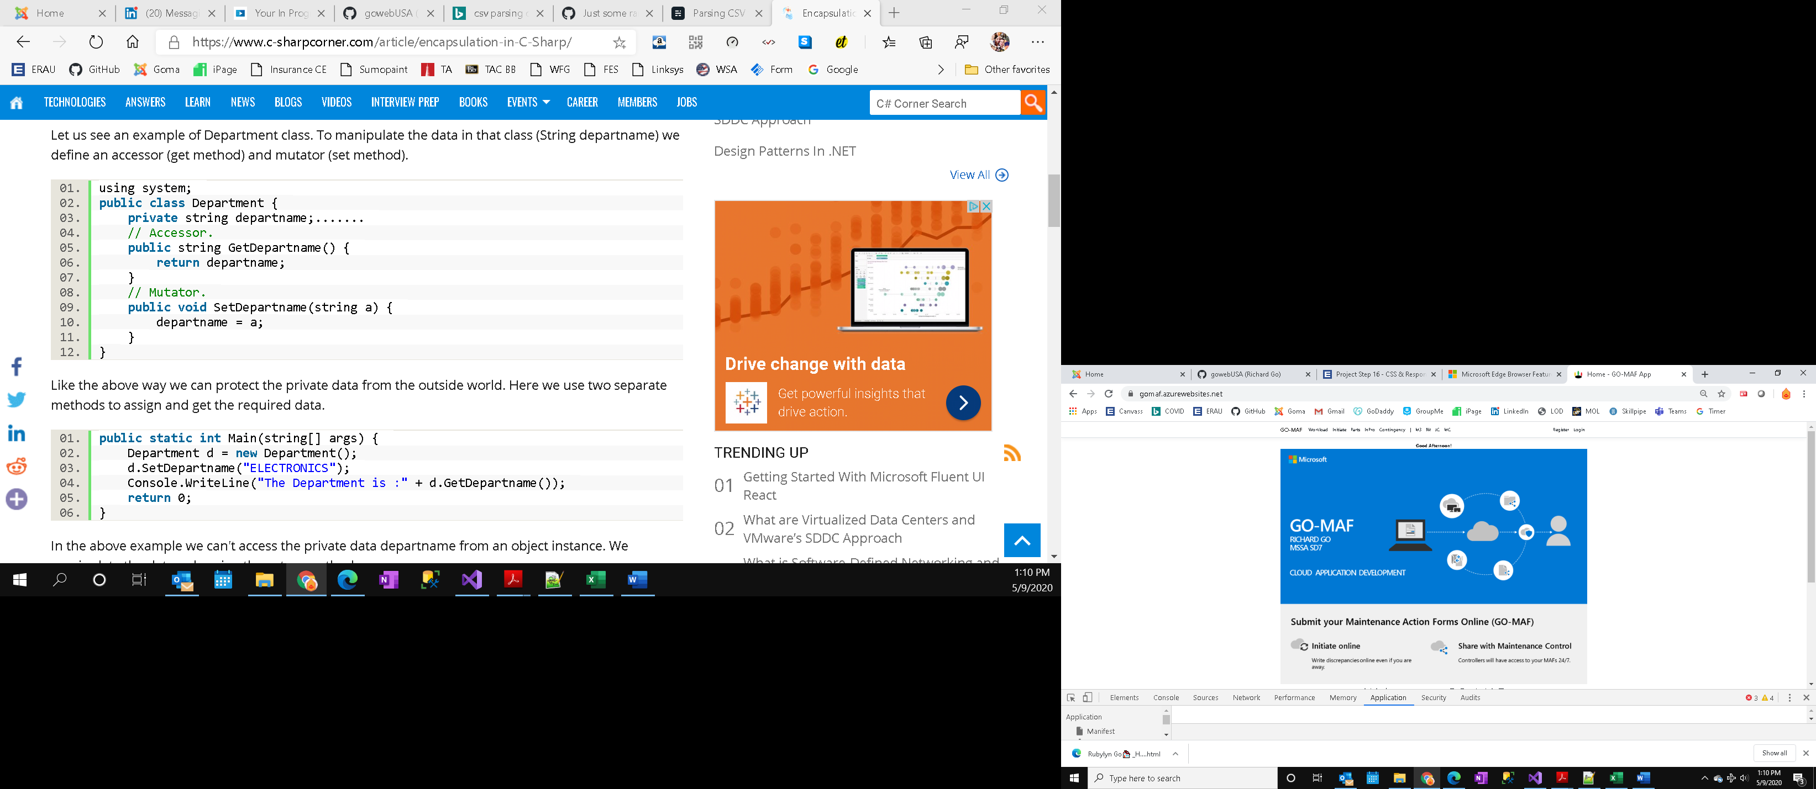

1. Mobile View (use the responsive design tool in Google Chrome browser)

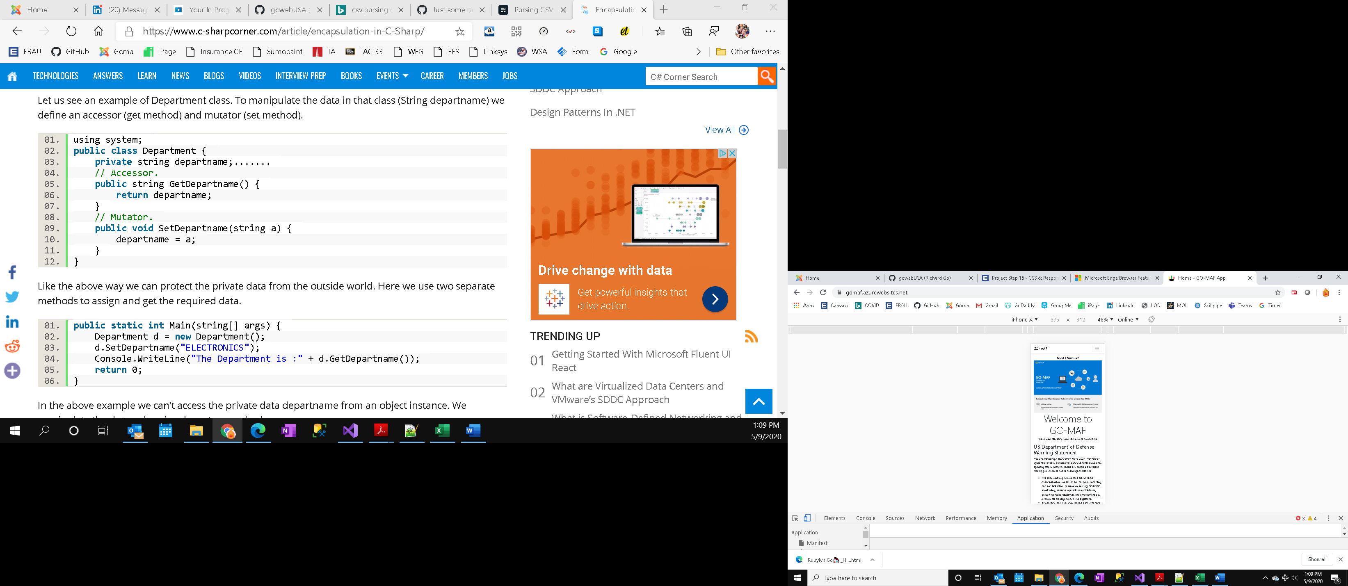

1. *Rotated* mobile view _for at least one or two pages (not a login screen) fpr your app. The text should indicate which of the approaches you used to enable responsive design.

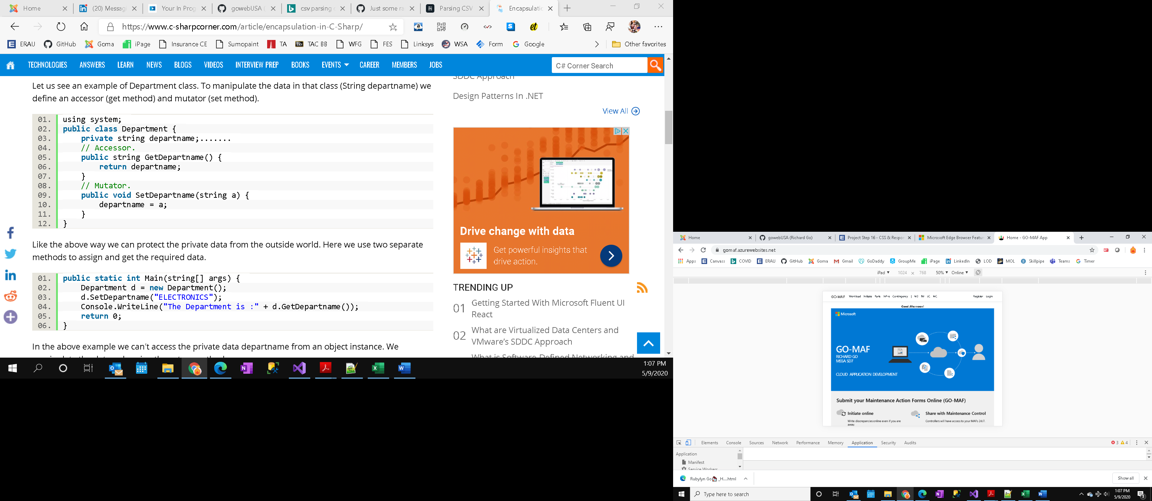

**Additionally!**

1. screenshot your next (Sprint 3?) week's sprint planning board

